**Lab 3 Report**

In this lab, we did Mashup application and Cloudera/Mapreduce and Cloudera/Mahout

In this report, I am going to post only an overview of what I did and I am posting a separate file for each of the three i.e., Mashup application, Cloudera/Mapreduce and Cloudera/Mahout in which I have given the detailed description about all the things.

**Mashup Application**

I did my Mashup application in Jsfidlle

<http://jsfiddle.net/b2AeL/4/>

This is the link where the coding part as well as the execution of the application can be seen

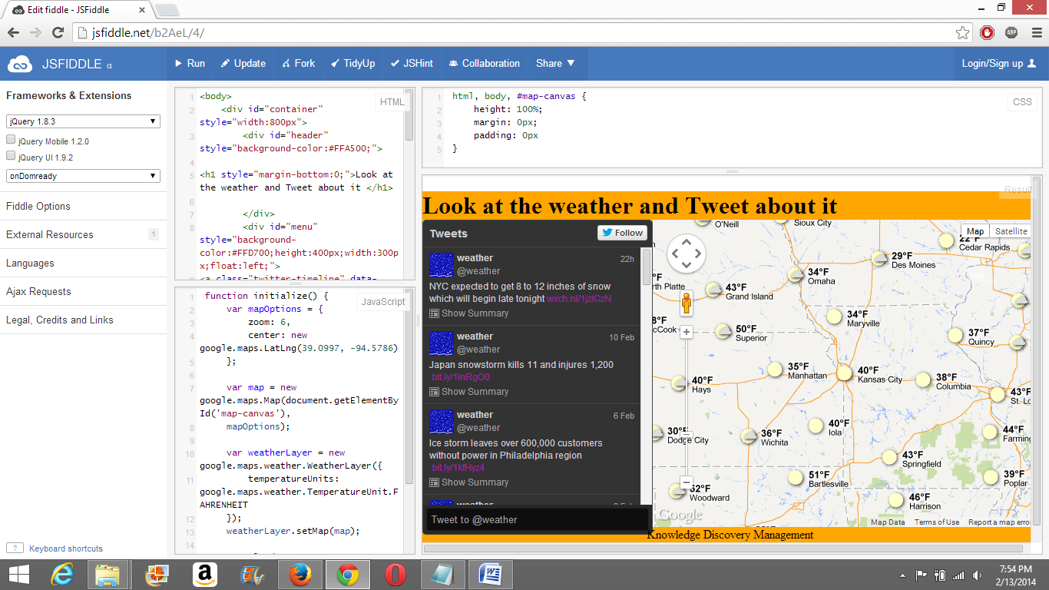

**Cloudera/MapReduce:**

Below are the screenshots of the hadoop word count

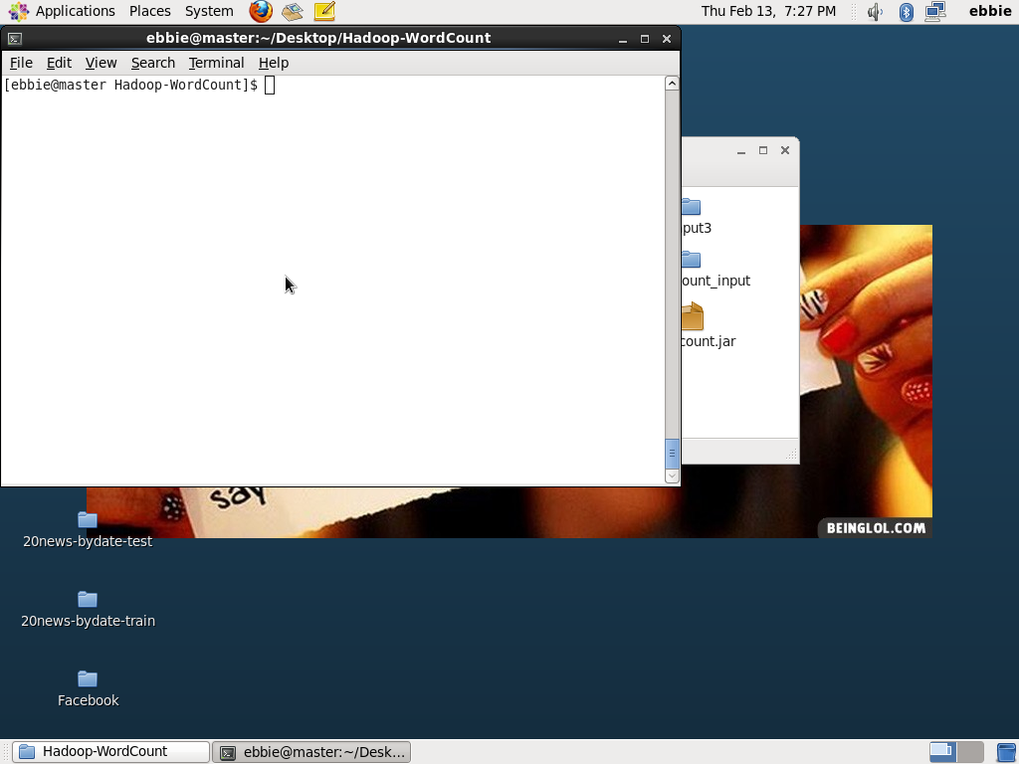

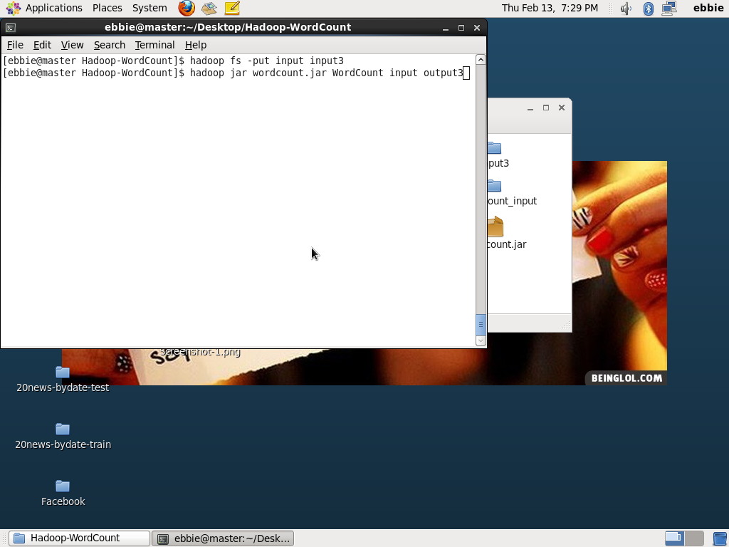

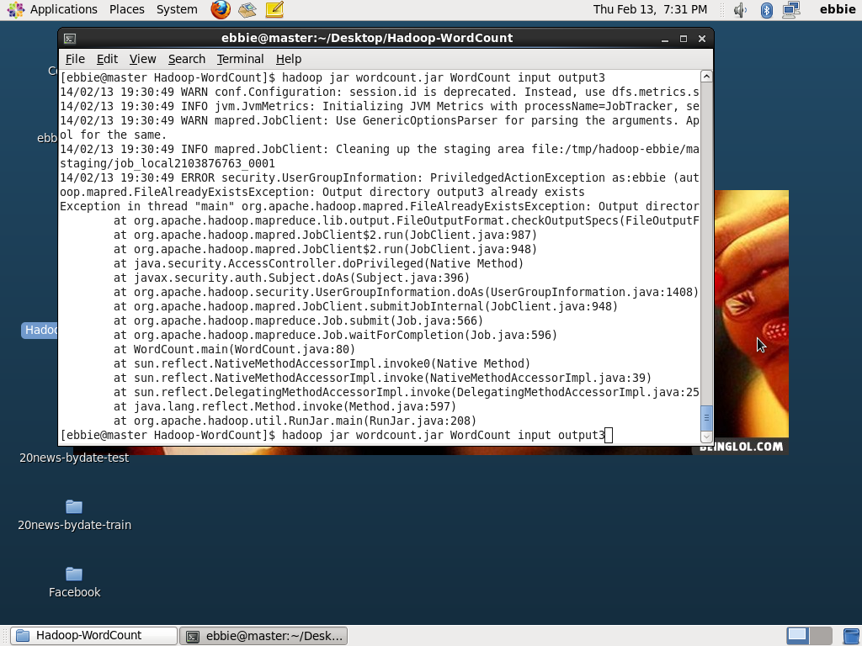

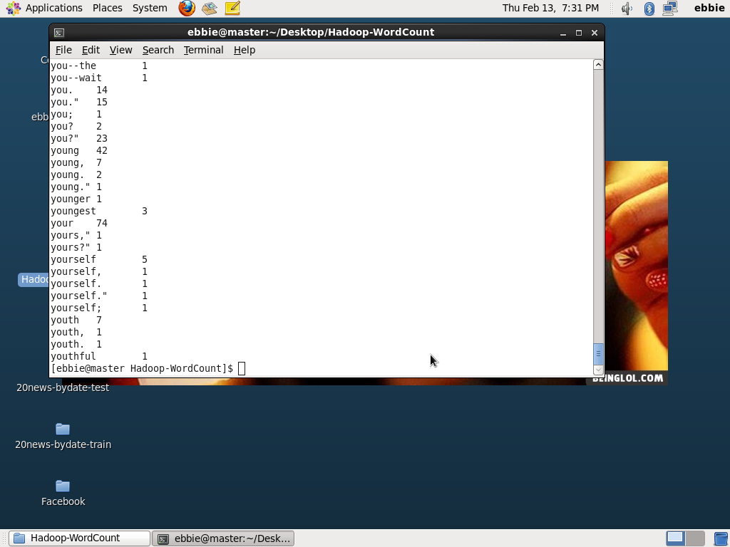

**MAHOUT**

Below are the screen shots of Mahout

